HOWTO: Install UniTrac (64-bit)

Summary
This document describes the steps required to perform an installation of UniTrac using the 64-bit installer. UniTrac supports a full installation onto one server, or a distributed installation onto separate servers for the website, database, and application service components.

Prerequisites
The following is needed before starting the UniTrac installation procedure.
- A DVD provided by Corp Ten or a download of the program installation file from a secure Corp Ten website.
- Local administrator privileges on the Windows server where UniTrac is to be installed.
- Sysadmin privileges on the Microsoft SQL Server database instance where the UniTrac database will reside.
- An X.509 (SSL) certificate, if SSL is desired for the UniTrac website.

System Requirements
UniTrac requires a Microsoft Windows server with Microsoft SQL Server.
- Windows Server 2012 R2 or 2016
  - See Appendix A: Required Roles & Features
  - ASP.NET MVC 1.0
- Microsoft SQL Server 2012 or 2014 (2016 is not currently supported)
  - Server collation must be set to SQL_Latin1_General_CP1_CI_AS
  - Authentication must be set to Mixed Mode, allowing both Windows and SQL authentication

How to Use This Guide
This document can be used to install UniTrac (64-bit) onto a single server, or distributed across up to three servers. There are three primary sections: Pre-Installation Setup, Installation Procedures, and Post-Installation Configurations. Each section is tagged with an “Applies to” note, indicating whether that section is applicable to some or all of the installation modes. Pay special attention to ensure that the proper configurations are applied (or not applied) for the component that you are working with.

Pre-Installation Setup
This section describes the pre-installation steps necessary for UniTrac servers.

Create the UniTrac Service Account
[Applies to: Single Server, Administration Website, Link and Web Services, Database]
UniTrac supports the use of a service account created locally on the Windows server, or on an Active Directory domain. The UniTrac installer will automatically apply the correct server security settings to the chosen account. For additional detail, see Appendix B: Service Account Minimum User Rights.
- Create a new Windows User Account named UTServices. Ensure that the password meets server or domain complexity requirements and is documented for future reference. Check the boxes for User cannot change password and Password never expires.

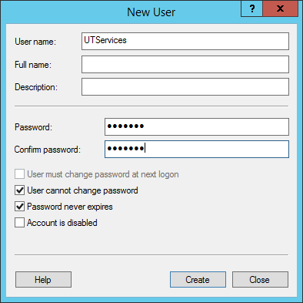

Install ASP.NET MVC 1.0
[Applies to: Single Server, Administration Website]
The UniTrac website requires the ASP.NET Model-View-Controller 1.0 framework for .NET 3.5.
- Download the ASP.NET MVC 1.0 installer MSI from Microsoft.
  - https://www.microsoft.com/en-us/download/details.aspx?id=5388
- Run the program by right-clicking on AspNetMVC1.msi and choosing Install.
- Choose the default options to complete the installation.

Configure the Microsoft Distributed Transaction Coordinator (MSDTC)
[Applies to: Link and Web Services, Database]
In distributed installations, the MSDTC is utilized to coordinate transactions between servers.
- Launch Component Services by browsing to Control Panel > Administrative Tools > Component Services, or by typing dcomcnfg at the Start screen or Run dialog.
- Expand the tree until you get to Local DTC. Right-click and select Properties.

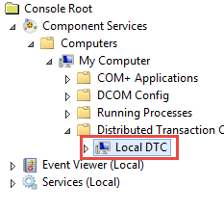

- On the Security tab, ensure the following options are selected.
  - Allow Inbound
  - Allow Outbound
  - No Authentication Required

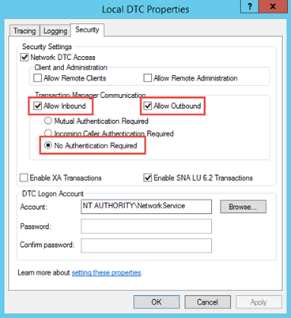

- Click OK to close the Local DTC Properties.

Configure the Windows Firewall for SQL Traffic
[Applies to: Database]
In distributed installations, the Windows Firewall must permit SQL traffic to and from the database server.
- Launch Windows Firewall with Advanced Security by browsing to Control Panel > Windows Firewall, then clicking Advanced settings on the left-hand pane.
- In the left-hand pane, select Inbound Rules. Then in the right-hand pane, click New Rule…
- Follow the prompts to create a new Port rule for TCP port 1433, allowing the connection.

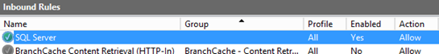

Installation Procedure (Single Server)
This procedure describes how to perform a full installation of UniTrac on one server.

Install UniTrac

- Launch the installer program by right-clicking on InstallUniTrac.bat and choosing Run as Administrator.
- On the Welcome screen, click Next.

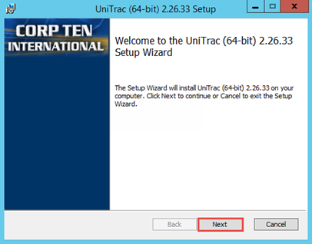

- Read and accept the End User Licensing Agreement (EULA) by checking the box. Click Next.

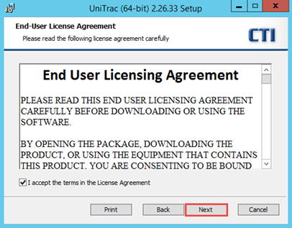

- To install all of the UniTrac components onto one server, click Next. For installation to separate servers, see Installation Procedure (Separate Servers).

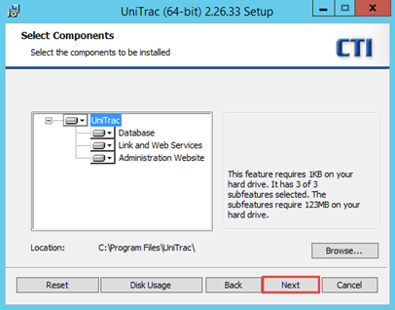

- Enter the SQL Server credentials that will be used by the installer to create the UniTrac database. A Windows or SQL Server login with sysadmin privileges is required. Click Next.
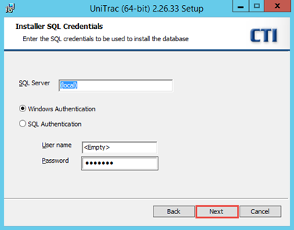

  - SQL Server: The name of the database server where the database will be created. The use of (local) will direct the installer to the local server and default database instance. If a different server or instance name is in use, type the full name in the format SERVERNAME\INSTANCENAME.
  - Windows Authentication: If the Windows account you are using to install UniTrac has sysadmin privileges within SQL Server, select this option.
  - SQL Authentication: If you wish to provide SQL Login credentials for the installation of UniTrac, select this option and type the login’s User name and Password in the boxes below.

- Provide the username and password of the UniTrac service account created in the Pre-Installation Setup. By default, UTServices is populated as the username. The password must be entered manually.

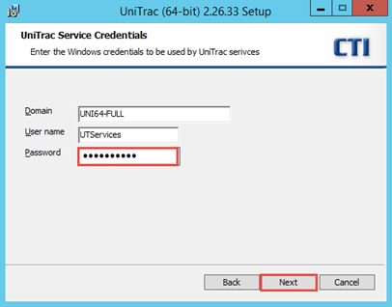

  - Domain: If the UniTrac service account was created on the local computer, enter the computer name here. If the service account is a domain account, enter the domain name.
  - User name: Enter the Windows account name of the UniTrac service account that you created above.
  - Password: Enter the password for the UniTrac service account. Do not leave the default asterisks – clear this text box and type or paste the password for the service account.

- Enter the SQL Server credentials that will be used by UniTrac to access the database. Leaving the default option will allow UniTrac to access the database using the Windows service account. This is recommended in most cases. Click Next.

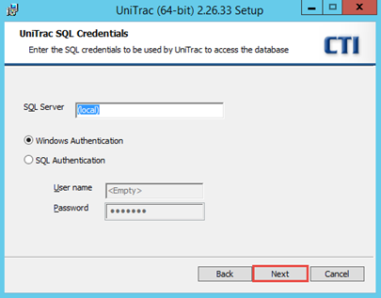

  - SQL Server: The name of the database server where the UniTrac database is located. The use of (local) will direct the installer to the local server and default database instance. If a different server or instance name is in use, type the full name in the format SERVERNAME\INSTANCENAME.
  - Windows Authentication: Selecting this option directs UniTrac to use the UniTrac Windows service account to access the database.
  - SQL Authentication: If you wish to provide SQL Login credentials for UniTrac to use for accessing the database, select this option and type the login’s User name and Password in the boxes below.

- Accept the default HTTP Port for the UniTrac website, or modify the port number if desired. HTTPS is configured later in this document, after which HTTP is not used.

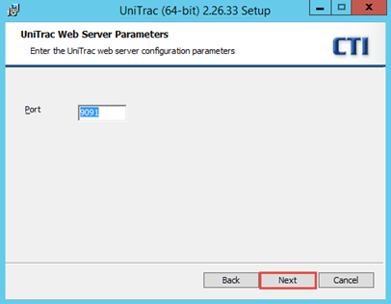

- Click Install to begin the installation.

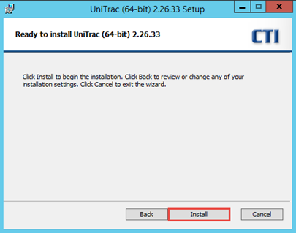

- When the installation has completed successfully, you will be presented with the completed setup screen. Click Finish.
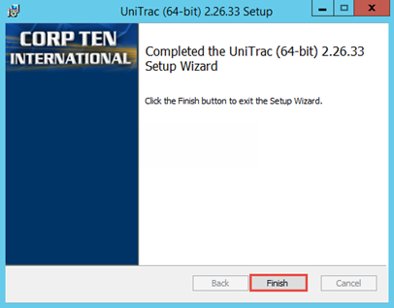
- If there is an unrecoverable error during the installation, the installer provides an error message and rolls back the installation. Gather the log data by browsing to the directory containing the UniTrac installer file, and making a copy of the UnitracInstall.log file.
- Follow the Post-Installation Configuration procedure for a Single Server.

Installation Procedure (Separate Servers)
This procedure describes how to perform a distributed installation of UniTrac on separate servers. This allows for common best-practice configurations such as placing the database on a machine that is separately firewalled from the Internet or DMZ.

Install the UniTrac Database

- Launch the installer program by right-clicking on InstallUniTrac.bat and choosing Run as Administrator.
- On the Welcome screen, click Next.

- Read and accept the End User Licensing Agreement (EULA) by checking the box. Click Next.

- Deselect the Link and Web Services and Administration Website components, and click Next.

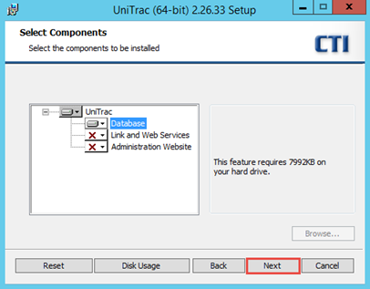

- Enter the SQL Server credentials that will be used by the installer to create the UniTrac database. A Windows or SQL Server login with sysadmin privileges is required. Click Next.

  - SQL Server: The name of the database server where the database will be created. The use of (local) will direct the installer to the local server and default database instance. If a different server or instance name is in use, type the full name in the format SERVERNAME\INSTANCENAME.
  - Windows Authentication: If the Windows account you are using to install UniTrac has sysadmin privileges within SQL Server, select this option. It is not necessary to enter a User name or Password when using this option.
  - SQL Authentication: If you wish to provide SQL Login credentials for the installation of UniTrac, select this option and type the login’s User name and Password in the boxes below.

- Provide the credentials of the Windows user account or SQL login that UniTrac will use to access the database.

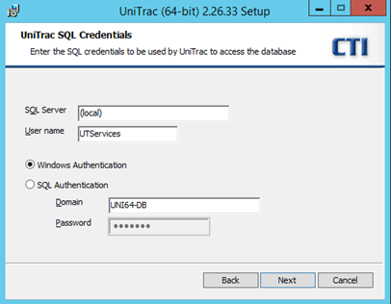

  - SQL Server: The name of the database server where the UniTrac database is located. The use of (local) will direct the installer to the local server and default database instance. If a different server or instance name is in use, type the full name in the format SERVERNAME\INSTANCENAME.
  - User name: The Windows user name or SQL login name that UniTrac will use to access the database. Typically this is the UniTrac service account name.
  - Windows Authentication: Selecting this option directs UniTrac to use the UniTrac Windows service account to access the database. If the UniTrac service account is a domain account instead of a local account, enter the domain name in the Domain box below.
  - SQL Authentication: If you wish to provide SQL Login credentials for UniTrac to use for accessing the database, select this option and type the login’s User name and Password in the boxes. The Domain box will become read-only as it does not apply for SQL authentication.

- Click Install to begin the installation.

NOTE: In some instances, error 28101 is displayed during database installation. Clicking OK on the error dialog will bypass the error and allow the installation to continue normally. It can be safely ignored.

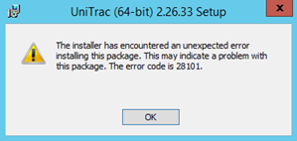

- When the installation has completed successfully, you will be presented with the completed setup screen. Click Finish.

- If there is an unrecoverable error during the installation, the installer provides an error message and rolls back the installation. Gather the log data by browsing to the directory containing the UniTrac installer file, and making a copy of the UnitracInstall.log file.
- Follow the Post-Installation Configuration procedure for the Database.

Install the UniTrac Link and Web Services

- Launch the installer program by right-clicking on InstallUniTrac.bat and choosing Run as Administrator.
- On the Welcome screen, click Next.

- Read and accept the End User Licensing Agreement (EULA) by checking the box. Click Next.

- Deselect the Database and Administration Website components, and click Next.

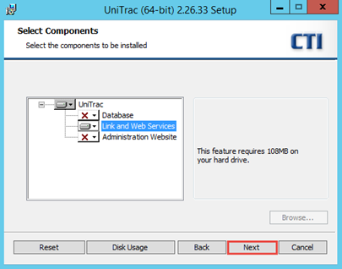

- Provide the username and password of the UniTrac service account created in the Pre-Installation Setup. By default, UTServices is populated as the username. The password must be entered manually.

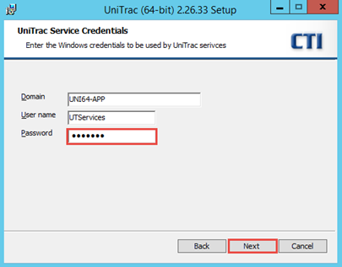

  - Domain: If the UniTrac service account was created on the local computer, enter the computer name here. If the service account is a domain account, enter the domain name.
  - User name: Enter the Windows account name of the UniTrac service account that you created above.
  - Password: Enter the password for the UniTrac service account. Do not leave the default asterisks – clear this text box and type or paste the password for the service account.

- Enter the SQL Server name and user credentials that will be used by UniTrac to access the database. Leaving the default option will allow UniTrac to access the database using the Windows service account. This is recommended in most cases. Click Next.

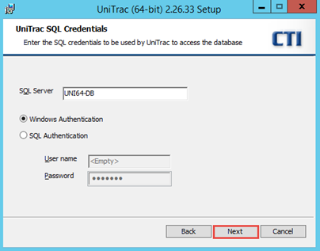

  - SQL Server: The name of the database server where the UniTrac database is located. The use of (local) will direct the installer to the local server and default database instance. If a different server or instance name is in use, type the full name in the format SERVERNAME\INSTANCENAME (Instance name is not required if it is the default instance).
  - Windows Authentication: Selecting this option directs UniTrac to use the UniTrac Windows service account to access the database.
  - SQL Authentication: If you wish to provide SQL Login credentials for UniTrac to use for accessing the database, select this option and type the login’s User name and Password in the boxes below.

- Click Install to begin the installation.

- When the installation has completed successfully, you will be presented with the completed setup screen. Click Finish.

- If there is an unrecoverable error during the installation, the installer provides an error message and rolls back the installation. Gather the log data by browsing to the directory containing the UniTrac installer file, and making a copy of the UnitracInstall.log file.
- Follow the Post-Installation Configuration procedure for the Link and Web Services.

Install the UniTrac Administration Website

- Launch the installer program by right-clicking on InstallUniTrac.bat and choosing Run as Administrator.
- On the Welcome screen, click Next.

- Read and accept the End User Licensing Agreement (EULA) by checking the box. Click Next.

- Deselect the Database and Link and Web Services components, and click Next.

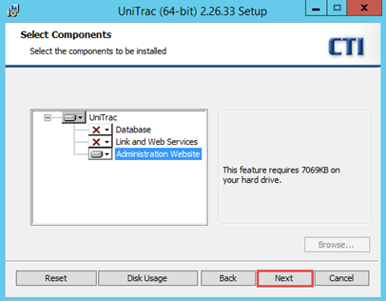

- Provide the username and password of the UniTrac service account created in the Pre-Installation Setup. By default, UTServices is populated as the username. The password must be entered manually.

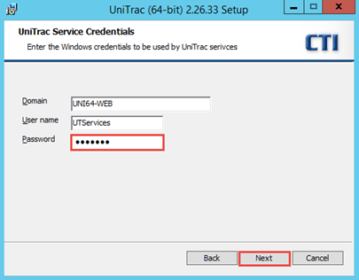

  - Domain: If the UniTrac service account was created on the local computer, enter the computer name here. If the service account is a domain account, enter the domain name.
  - User name: Enter the Windows account name of the UniTrac service account that you created above.
  - Password: Enter the password for the UniTrac service account. Do not leave the default asterisks – clear this text box and type or paste the password for the service account.

- Accept the default HTTP Port for the UniTrac website, or modify the port number if desired. HTTPS is configured later in this document, after which HTTP is not used.

- Click Install to begin the installation.

NOTE: In some instances, error 28101 is displayed during website installation. Clicking OK on the error dialog will bypass the error and allow the installation to continue normally. It can be safely ignored.

- When the installation has completed successfully, you will be presented with the completed setup screen. Click Finish.

- If there is an unrecoverable error during the installation, the installer provides an error message and rolls back the installation. Gather the log data by browsing to the directory containing the UniTrac installer file, and making a copy of the UnitracInstall.log file.
- Follow the Post-Installation Configuration procedure for the Administration Website.

Upgrade Procedure
UniTrac upgrades are performed in the same manner regardless of whether it is a single server or distributed installation. The upgrade installer must be run on each server hosting UniTrac components. In general, UniTrac upgrades are cumulative and it is possible to upgrade to a current release without applying any intermediate releases.
For distributed installations upgrade the database first, before upgrading the other components.

Upgrade UniTrac

- Before performing any upgrade installations, it is necessary to stop the UniTrac services found on a Single Server or Link and Web Services installation. This can be done by manually stopping the Windows services, or by running the included script at an administrative command line as follows:
C:\Program Files\UniTrac>cscript /nologo svcs.vbs /stop /vb

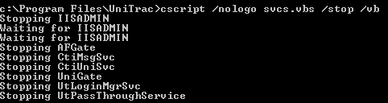

This helps to ensure that no UniTrac files will be in use while the installations are running, which could prevent the program from upgrading properly.

- Launch the installer program by right-clicking on InstallUniTrac.bat and choosing Run as Administrator.

- On the Welcome screen, click Next.

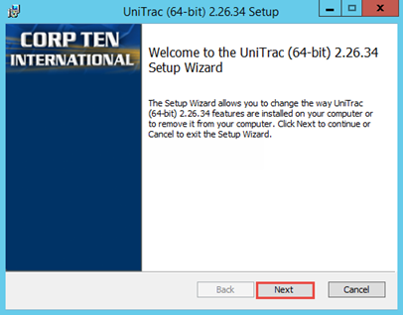

- On the Change, repair, or remove installation screen, click Repair.

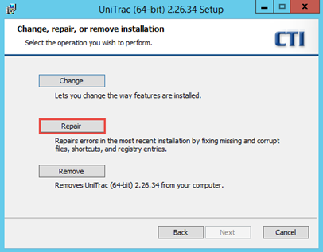

- On the Ready to repair UniTrac screen, click Repair.

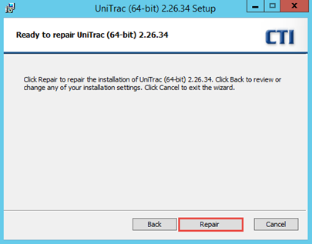

- When the installation has completed successfully, you will be presented with the completed setup screen. Click Finish.

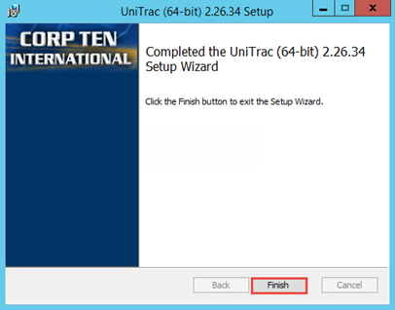

  - If there is an unrecoverable error during the upgrade installation, the installer provides an error message and rolls back the installation. Gather the log data by browsing to the directory containing the UniTrac installer file, and making a copy of the UnitracReinstall.log file.

- Restart Windows to complete the UniTrac upgrade.

Post-Installation Configuration
This procedure describes the post-installation steps necessary for UniTrac servers.

Apply the UniTrac License
[Applies to: Single Server, Link and Web Services]
The UniTrac software must be licensed before it will operate. Use the following steps to generate a license request string and apply the license key.
- Open Windows Explorer and browse to the UniTrac installation directory, typically C:\Program Files\UniTrac.
- Launch LicSet.exe by right-clicking and selecting Run As Administrator.
- Copy the string provided in the top text box, and send it to Corp Ten to request a license be generated from that string.
IMPORTANT: Do not close the Set License dialog box while waiting for your license key. Closing this box will cause the provided string to become invalid, and the process will need to be repeated.

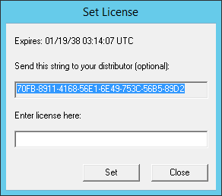

- After receiving your license key from Corp Ten, paste or type it into the bottom text box and click Set.

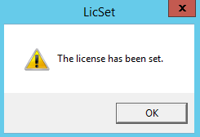
- Click OK, then click Close to complete the licensing process.

Configure the UniTrac Website for SSL
[Applies to: Single Server, Link and Web Services, Administration Website]
It is necessary to configure the UniTrac website for SSL. Though it installs for HTTP by default, it will not fully function until an SSL certificate is configured and applied. A self-signed certificate generated within IIS is suitable for testing purposes, until a certificate can be obtained from a publicly-trusted certificate authority.
- Install your SSL certificate to the UniTrac server according to your certificate vendor’s recommended procedure. Be sure to install any required Root or Intermediate certificates for the certificate chain.
- Launch Internet Information Services (IIS) Manager and select the Unitrac Web Applications and Services website.
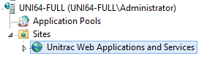
- Locate the Edit Site menu on the right-hand side of IIS Manager and click Bindings…
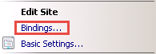
- In the Site Bindings window, click Add.

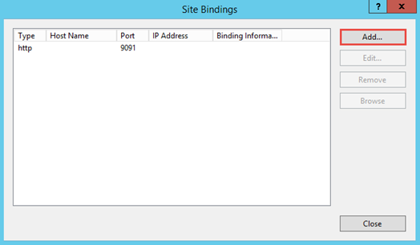
- Select https from the Type drop-down box, and click the SSL certificate drop-down box to select your previously-imported SSL certificate. Leave the default Port setting of 443 or if desired, enter a different port number.

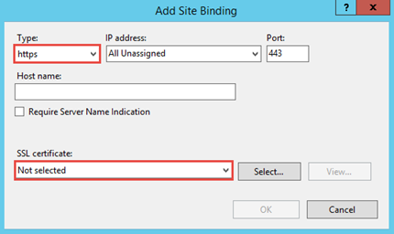
- After you’ve selected your SSL certificate, click OK. Then, click Close to exit the Site Bindings menu.
- If desired, you can remove the HTTP binding, as it is not needed.

Configure the UniTrac Core Services
[Applies to: Single Server, Link and Web Services]
UniTrac installs numerous Windows services that are required for basic operation and connectivity with tracking hardware. This procedure will configure the basic required services.
- Browse to the Windows services control panel.
- Set each of the following services to the Automatic Startup Type, and then Start the service.
  - CtiUniSvc
  - CtiMsgSvc
  - UniGate
  - UtLoginMgrSvc
  - UtPassThroughService
- This process will also need to be performed for any UniTrac link services that you intend to use, however that configuration is beyond the scope of this document.

Configure the AutoFind Gateway
[Applies to: Single Server, Link and Web Services]
The AutoFind Gateway Service (AFGate) is used for connectivity to other Corp Ten applications such as AutoFind Web or Evolution.
- Open the Windows Registry Editor and browse to HKLM\SOFTWARE\Corp Ten International\UniTrac Services\CtiUniSvc.
- Note the list of QueueOut#Name and QueueOut#Queue key values, representing Microsoft Message Queues that have been installed by UniTrac.
- Looking at the Data column, locate the Name and Queue pair for .\PRIVATE$\AFGate. There will be two such Queue values in the listing however only one will have the Name value of afgate_disabled. The Name/Queue numbers in the key name may be different on your installation.

- Once you’ve located afgate_disabled, edit the value of that key so that it is blank.

- Next, browse to HKLM\SOFTWARE\UniTrac\UniTrac Services\AFGate.

- Set a password for the AFGate connection by editing the value data of the Password key, and providing a suitable password. Initially appearing in plain text, this password will be encrypted when the AFGate service is started. You will need to provide this password during the installation process for other Corp Ten applications when connecting to UniTrac.

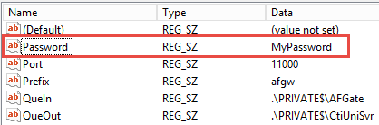

- Browse to the Windows services control panel.

- Set the AFGate service to the Automatic Startup Type, and then Start the service.

Set the UniTrac Data Retention Policy (Optional)
[Applies to: Single Server, Database]
By default, UniTrac retains device position reports for 90 days. This value can be configured within the UniTrac database if a different retention is desired. Note that longer retention periods will lead to larger database sizes over time.
- Launch SQL Server Management Studio (SSMS) and connect to the UniTrac database instance.

- Create a new query.

- To view the current data retention settings, execute the following statement in the new query window:
USE Unitrac
SELECT * FROM UNI_Params
- To modify the data retention settings, execute the following statement (modify the number value to the number of days you wish for UniTrac to retain data):

USE Unitrac
UPDATE UNI_Params
SET szValue = 365

Grant Folder Permissions to the UniTrac Service Account (Optional)
[Applies to: Single Server, Link and Web Services]
UniTrac uses Windows SMTP to send email for various device links, and database reports. The UniTrac service account requires write permission in order for this to function properly.
- Open Windows Explorer and browse to the IIS SMTP mailroot directory, typically C:\inetpub\mailroot.

- Right-click on the Pickup folder and select Properties.

- Select the Security tab and click the Edit button. Add your UniTrac service account name, granting Modify and Write permissions.

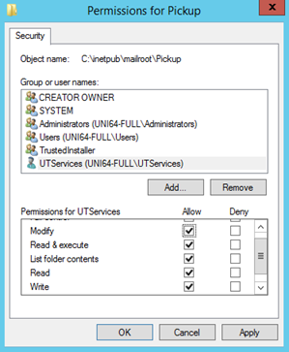

Grant Folder Permissions to the SQL Service Account (Optional)
[Applies to: Single Server, Link and Web Services]
UniTrac jobs configured within SQL Server use Windows SMTP to send email for database reports, when configured. If a custom service account was configured during SQL installation, it is necessary to grant that account permission to write the SMTP folder structure. If a custom service account was not defined during SQL installation (SQL Server is running as Local System), this configuration is unnecessary.
- Open Windows Explorer and browse to the IIS SMTP mailroot directory, typically C:\inetpub\mailroot.
- Right-click on the Pickup folder and select Properties.

- Select the Security tab and click the Edit button. Add your SQL Service account name, granting Modify and Write permissions.

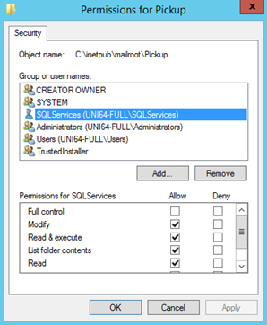
- Click OK to save your changes.

Configure the UniTrac UI to Connect to Remote Web Services
[Applies to: Administration Website]
In distributed installations, the UniTrac Administration Website may be located on a machine separate from the UniTrac Link and Web Services. In such instances, it is necessary to configure the website with the location of those services.

- Launch a text editor such as Notepad with Run as Administrator. Within the text editor, browse to C:\Program Files\UniTrac\WebApps\UtAdminUI and open Web.config. Within the Web.config file, locate the <client> section near the bottom of the file. It should appear as follows:
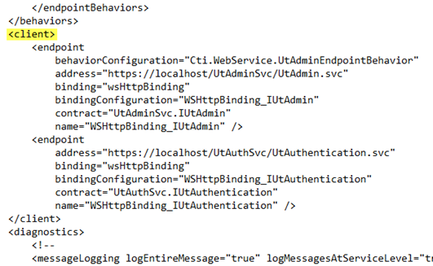
- Within each client endpoint configuration, note the localhost value within each address= line. Localhost must be updated to the IP Address, Host name, or Fully Qualified Domain Name (FQDN) of your Link and Web Services server.
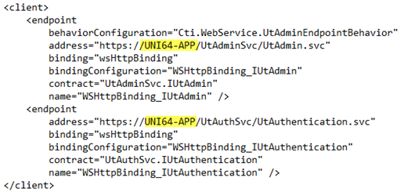
- Save the Web.config file and close the text editor.

Appendix A: Windows Server Required Roles & Features

Single Server
Output shown from Windows Server 2012 R2.

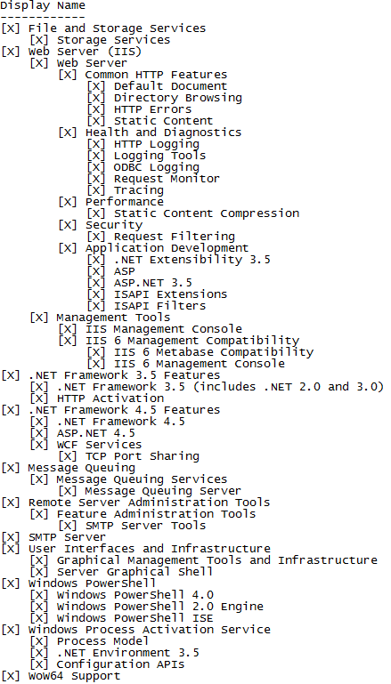

Web Server
Output shown from Windows Server 2012 R2.

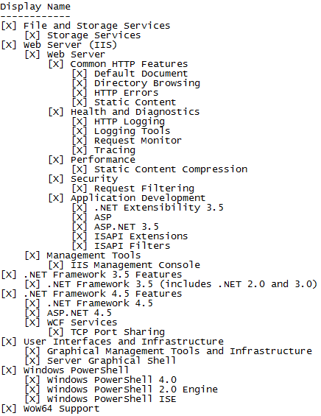

Separate Servers – Link and Web Services
Output shown from Windows Server 2012 R2. Note for Windows Server 2016: Distributed Transactions is installed by default and does not need to be selected in Roles & Features.

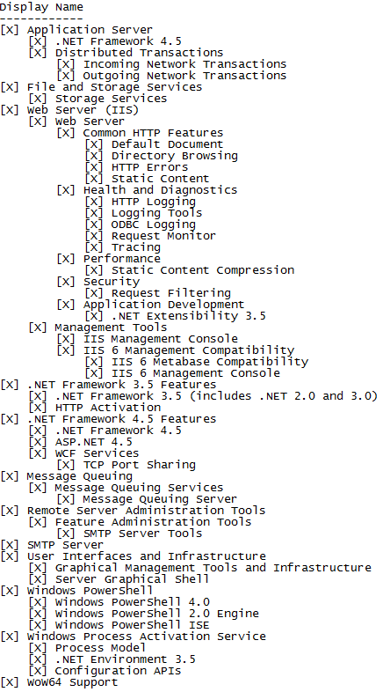

Separate Servers - Database
Output shown from Windows Server 2012 R2. Note for Windows Server 2016: Distributed Transactions is installed by default and does not need to be selected in Roles & Features.

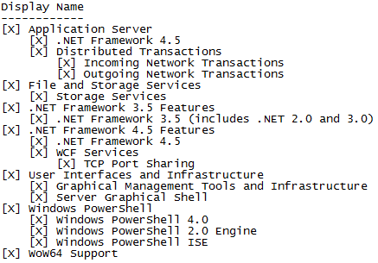

Appendix B: Service Account Minimum User Rights
The UniTrac service account must be a local or domain Windows User account with the following User Rights Assignments, at a minimum. These are configured automatically by the UniTrac installer.
Log on as a batch job
Log on as a service

Document Change History

Date | Version | Change Description | Change Author
2017-06-23 | 1.0.0 | Initial Release | TW

